Jason Jelicich
[Company name] [Company address]
KITCHEN ESSENTIALS

Table of Contents
- Kitchen Orientation
  - The Kitchen Environment
  - Mindset of a Professional Chef
  - Kitchen Health & Safety
  - Kitchen Workflow
  - Kitchen Roles & Responsibilities
  - Opening, Closing & Cleaning
  - Prep Lists
  - Weighing & Portioning

- Food Safety
  - Storage & Labelling
  - Fridges & Freezers
  - Cooking Temperatures
  - Cross Contamination
  - Daily & Monthly Kitchen Audits

- The Pizza Section
  - Welcome to the Pizza Section!
  - Section Equipment
  - Mise en Place
  - Making Dough
  - Making a Pizza

- The Fry Section
  - Welcome to the Pizza Section!
  - Section Equipment
  - Mise en Place
  - Cooking Chicken Schnitzel
  - Cooking Battered Fish & Chips
  - Closing & Cleaning

- The Pans Section
  - Welcome to the Pans Section!
  - Section Equipment
  - Filleting & Portioning Fish
  - Cooking Fish
  - Closing & Cleaning

- The Grill Section
  - Welcome to the Grill Section!
  - Mis en Place
  - Trimming & Portioning Steak
  - Cooking Steak
  - Closing & Cleaning

- The Pass
  - Welcome to the Pass
  - Managing dockets & customers
  - Managing complaints
  - Managing requests/ dietaries
  - Closing/ cleaning

Introduction
Welcome to the Kitchen Essentials course!

This course has been developed to provide you with a solid grounding in what it takes to work in (and run) a successful kitchen operation.

Whether you are brand new to the kitchen environment or already have some experience, Chef Paul and his crack kitchen team will walk you through essential skills and knowledge to build your confidence, increase your productivity and enhance your career potential.

This course has been developed to provide you with valuable insight into how a commercial kitchen operates. It is helpful to those who are:
- New to the kitchen
- Have some kitchen experience, or
- Are working in the front of house but who are interested learning more about the kitchen
It has been compiled and presented by working industry professionals who are invested in building your confidence and knowledge so that you can riser through the industry.

When someone cooks for you, they are saying something. They are telling you about themselves: Where they come from, who they are, what makes them happy.

- Anthony Bouordain

The Kitchen Environment

The success of the kitchen often dictates the success of the business.

To ensure the kitchen is running like a well-oiled machine and continuing to bring customers back to dine at your venue, 4 basic principles must be in place:
- Teamwork/ Team Environment: You must adopt under the 'one team, one dream' mindset.
- Preparation: Preparation is the key to a successful shift in a busy kitchen environment. If you fail to prepare - prepare to fail!
- Organisation: Keep and organised mind and organised work area 'A place for everything and everything in its place'.
- Communication: Owing to the fast-paced and late-night environments, excellent written and verbal communication skills are essential!

Front of house staff play a big role in the customer's overall dining experience so make sure to build and maintain a good rapport with them!

A quality food offering is one of the biggest reasons customers choose to visit a venue – and it drives sales for all other departments.

Mindset of a Professional Chef

The word Chef is derived from the word Chief - meaning the Boss!
What does it take to think and act like a professional chef?
Here are 6 attributes that will help to set you up for success in the kitchen (or at least help you understand your head chef better!)
Passion
Being a chef requires a lot of hard work and longer hours than most other professions, so having a deep-rooted passion for your craft is essential.
This same desire is going to push you to continue honing your skills and improving; seeking out new techniques and recipes to stay on top of ever-changing trends.
Creativity
The daily challenges of a chef allow for an almost everlasting stream of creative possibilities to consider!
Be prepared to step out of your comfort zone and try new things, whether it be recipes, cooking techniques, plating etc. Mouth-watering presentation is now a standard in the world of dining, so be bold and allow your creativity to flow!
Teamwork
Teamwork has been the key to success for every successful sports team in history!
With every player on the team working together for the same goal and doing their individual jobs to the best of their abilities, a team will achieve success.
This same approach applies to working in the kitchen, even with its apparent hierarchy of talent and renown, your role is integral to the overall success of the operation.
Perform under Pressure
Having a cool head amid immense pressure is an invaluable skill!
Working in a busy restaurant can often be hectic. While it is easy to get overwhelmed, you are ultimately in control of how much stress you experience.
Honing your techniques and having more confidence decreases time in preparing ingredients and plating orders, allowing you to surf the wave of pressure rather than being consumed by it!
Ability to take Criticism
Don't shy away from what people have to say, and instead, choose to turn it into something you can learn from and modify in the future to be better.
Chefs are always changing their recipes and techniques to accommodate constructive criticism.
Detail Oriented
From the creation of a dish to the plating of the food, attention to detail is a critical component.
From the creation of a dish to the plating of the food, attention to detail is a critical component.
There is a science to cooking, and if recipes aren’t closely tended to, they can easily go awry. Plating and presentation often require a chef to be a bit of a perfectionist with the smallest of details from garnish to a singular rogue hair present in food could ruin a perfect dish for someone.
Successful chefs know how to focus. This does not go against the need for creativity and changing your style by any means. It does, however, mean that there is an undeniable importance to paying close attention to detail.

Kitchen Health & Safety
Food quality and health & safety go hand-in-hand.
The kitchen can be a busy and often chaotic place but despite this, we cannot compromise on maintaining a safe and hygienic environment.
Here are a few potential hazards to be aware of - and common-sense strategies to avoid them!
Cross Contamination
Hand washing is the most effective way to limit or avoid cross contamination and food poisoning issues.
You should always wash your hands:
- Before and after you handle any food
- After you have been to the bathroom
- After you have been smoking
Steps to washing your hands correctly:
- Wet your hands and then apply soap
- Lather your hands, including between fingers
- Scrub your hands for 20 seconds
- Rinse your hands
- Dry your hands thoroughly

Burn Hazards
Everything seems hot in a busy kitchen, and carelessness or rushing will more than likely result in a burn injury. It's critical to practice the following behaviours to ensure you and your colleagues remain safe.
- Make sure when lifting pans or pots you use a dry cloth.
- Always say behind when you are walking behind someone cooking and they can’t see you.
- Always say corner if you are caring a hot item and are out of site coming around corners.
- Make sure oils have cooled before handling or moving.
- If you have to lift or move pots of hot oil make sure to always have someone to help you.
- Always keep a safe distance when using cooking oils and fats can splatter.

Machine Injury
To avoid injuries from kitchen equipment, make sure to familiarise yourself with all commonly used equipment and read any instruction notes or manuals.
If you are not sure how to use a particular machine, make sure to request training from an experienced staff before using it.

Slips, trips, and falls
Despite our best efforts, the kitchen can also be a slippery place.
To avoid slipping and injuring yourself, make sure to wear enclosed, nonslip shoes, walk at a steady pace and always be aware of your surroundings.
NEVER RUN IN THE KITCHEN!

Lifting Injuries
There are many heavy items in the kitchen including pots, stock, machinery etc. and this is why lifting injuries are so common.
When lifting anything heavy, make sure to bend your knees when lifting and keep you back straight.
If there is an item that is too heavy, you must call someone to help you i.e. don't be a hero!

Obstacles & Obstructions
A busy kitchen has a lot of moving parts, and it's very easy for bins, trolleys, boxes and stock to end up crowding the workspace and creating a hazard.

If you spot something that shouldn't be there, take a few seconds to stow it away and clear the area - it may just save you (or one of your workmates) a serious injury!

Chemical hazards
Chemical products are the most hazardous substances you will be using in the kitchen. From machine washing agents, to degreasing and sanitising products, it imperative you wear the recommended Personal Protective Equipment (PPE) and follow the safety guidance on the Safety Data Sheets (SDS).

Fire hazards
Kitchen fires can happen so make sure to familiarise yourself with the fire safety plan on how to extinguish fires and be aware of where all fire safety equipment is stored in the kitchen.

Electric Shock
The biggest risk here is wet hands near electrical wiring. Always double-check that your hands are dry before handling electrical equipment and if you see a piece of equipment (e.g. exposed wiring) that needs attention to remove it from circulation and report to the manager on shift.

Kitchen Sections
When starting in any kitchen it is important to orientate yourself to the new environment and understand how the area works.
In this section, we will cover the basics regarding:
- Kitchen sections
- Kitchen workflow
- Roles & responsibilities
- Opening & closing
Firstly, let’s look at the kitchen sections and how they all work together to turn the kitchen into a well-oiled machine.
- The Scullery: This is where crockery and all utensils get cleaned.
- The Larder Section: This section is mainly used for preparing salads and cold entrees.
- The Fry Section: This is where all deep-fried dishes are cooked and prepared.
- The Pizza Section: This is where pizzas are cooked and prepared (duh!)
- The Pans Section: This is where most main and pasta dishes are cooked and prepared.
- The Grill Section: Where most steaks and fish get cooked and prepared.
- The Pass: Where all food is served to front of house.
Each section takes a specific set of skills and it's important you master each section before moving onto the next.

Kitchen Workflow
Kitchen workflow refers to an organised rhythm of activities which ensure that stock does not run out and customer expectations are met or exceeded.
Great kitchen workflow: Keeps everyone on the same page, preventing miscommunication, confusion, and frustration.
Poor kitchen workflow: Products run out, things get missed causing needless stress and negatively impacts the customer experience.
The flow chart below follows the arrival and storage of stock, through to it's eventual plating and serving. This is a standard workflow for all kitchens.
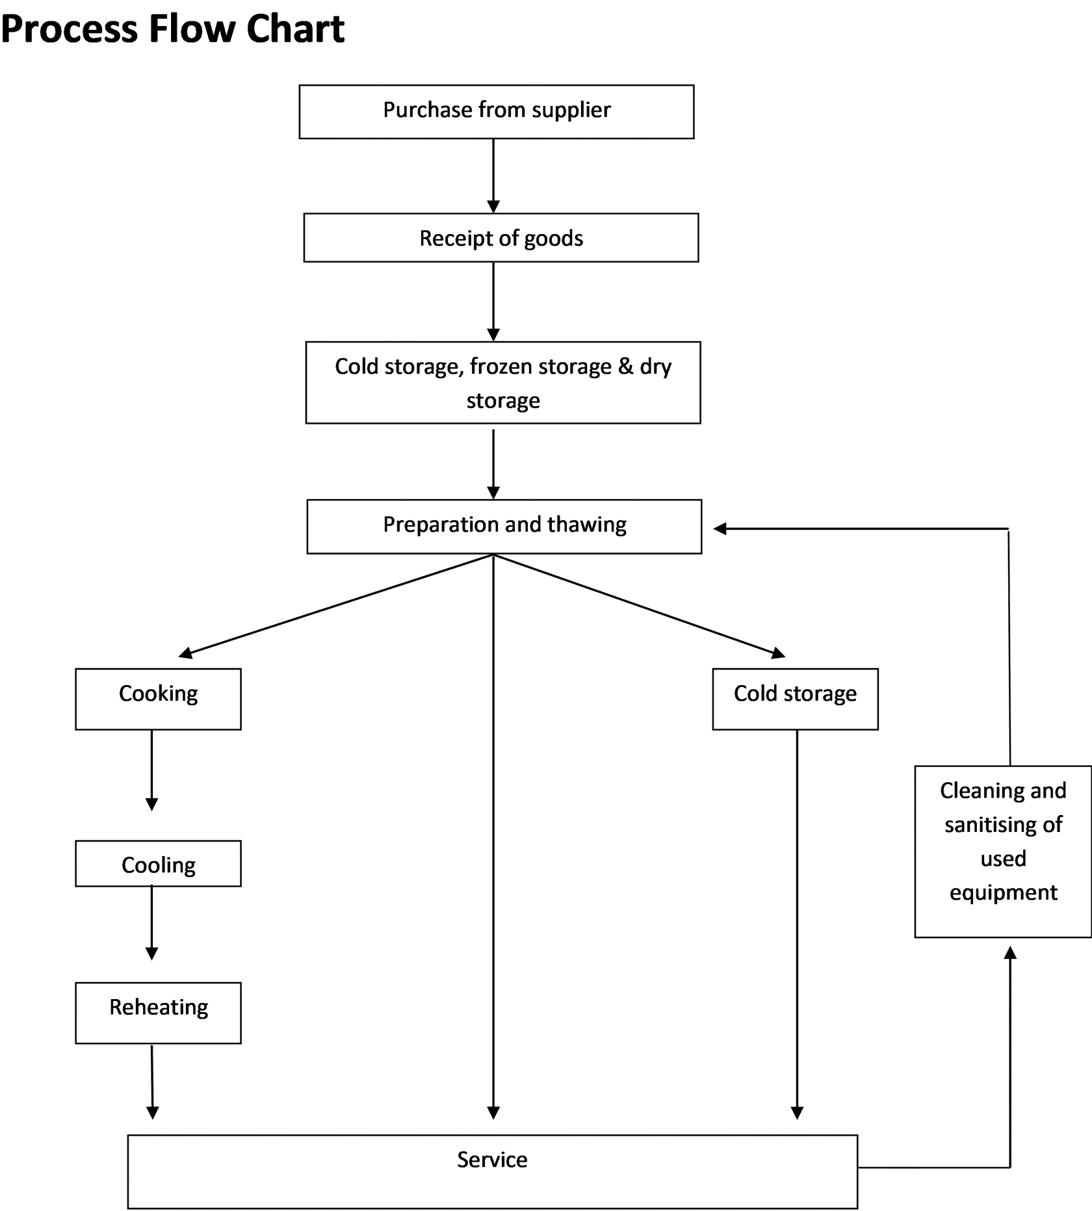

A great kitchen workflow keeps everyone on the same page, preventing miscommunication, confusion, and frustration.

Kitchen Roles & Responsibilities
The various roles in the kitchen may be compared to the various parts of a body. Every part is needed for the overall body to function effectively.
Here's a breakdown of the most common kitchen roles and their responsibilities:
- Head chef (Brains): Responsible for all aspects of running the kitchen from menu design, rostering, financials, and staff management.
- Sous chef (Muscle): Responsible for running the kitchen on a ground level from staff development and training, menu development, managing the flow of service, and management of food safety procedures.
- Chef de Partie (Heart) Responsible for managing a section, stock management, food preparation, cooking, and kitchen cleanliness and maintenance.
- Cook (Legs) Responsible for stock management, food preparation, cooking, and kitchen cleanliness and maintenance.
- Kitchen Hands (Hands) Responsible for equipment and utensils maintenance and cleanliness, stock management, food preparation, kitchen cleanliness and minor equipment maintenance.
The Kitchen Hand (or Dishy) is the most underrated role in the kitchen, and they deserve our support and assistance.

Opening, Closing & Cleaning
How we open, close and clean a kitchen determines how well the overall operation performs. Poor procedures will lead to a breakdown of service, food hygiene issues and lost customers.
While every kitchen is different, here are some essentials that apply no matter the location.
Cleaning and organising is a practice not a project - Megan Francis
Opening
Excellent preparation is the key to a successful shift and ensures the continuity of food service and happy customers. Always set yourself and your team up for success!
Opening the Kitchen
- Arrive: 5 mins early is on time and on time is late!
- Report: To the chef in charge for briefing on the shift ahead, including any functions and prep required.
- Check: Check the prep list to see what is required for the shift.
- Receive: Receive and/ or store any stock that may have been delivered prior to you starting.
- Start Prep: Complete your prep and organise your section ready for the shift.
- Switch on: Turn on your kitchen equipment and check it's all functioning as expected.
- Gametime! Open your section and put your awesome talents on display!
Note: It’s important to leave your problems at the door and focus on the work to be done to set yourself and your team up for success.

Closing & Cleaning
Closing is just as important as opening as you are setting yourself up ready for the next shift. If the close is not correctly completed it just sets the next shift up to fail, which impacts on your colleagues and the business.
Closing and cleaning are two sides of the same coin. A poorly cleaned kitchen creates health and safety issues e.g. cross-contamination and slip injuries. Additionally, your equipment may malfunction or break-down if it’s not cleaned and maintained regularly causing a multitude of avoidable service issues.
Closing & Cleaning the Kitchen
- Break-down: Break down your section and send all cooking utensils to wash up area.
- Turn off: Turn off equipment and allow to cool.
- Top-up: Top-up prep in clean containers for next service.
- Scrub: Scrub and sanitise all equipment, all benches and surfaces with the correct chemicals.
- Replenish: Replenish utensils and set up ready for next day service.
- Prep/ Order List: Complete prep list and orders in readiness for the next shift.
- Report: Report to chef in charge to hand over any prep and order list and to debrief on service.
- Hometime! Leave your kitchen immaculate and get home to relax!

Prep Lists
Prep lists are an important use of written communication between kitchen staff shift to shift.
They are used to make sure kitchens are prepared and do not run out of essential food items that may impact on availability of dishes and therefore the customer experience.
See an example of a typical prep sheet below and click on numbers to identify key areas.

- Name: Prep list should be filled out at the end of every service with the name of the person who completed it.
- Date: Date the sheet is being completed.
- Food Items: Items that need to be prepped for the next day’s service.
Note: It is best practice to also add some sort of identifier for any items that are urgent e.g. highlight or asterix with a note.

Weighing & Portioning
Portion control is an essential element of food cost and quality control. It reduces food waste, ensures a consistent and quality product, expedites food preparation and service, and has a big impact on food cost.
Portioning is the key to the consistency of product and the management of food costs.
Tips for using the scales:
- Always use clingwrap/ a separator - don't put food directly onto the scales.
- Always reset the scales before weighing.
- Be aware of a small margin of error i.e. 3%.

Food Safety
Food safety may not be the most glamourous topic, but it is of vital importance in a commercial kitchen environment.
This section will cover the essential elements of food safety, namely;
- Storage and labelling
- Fridge and freezer management
- Cooking temperatures
- Cross-contamination
- Daily & monthly kitchen audits

Storage & Labelling
Storage of food is very important and assists with the longevity of the product.

Storage
All prep must be stored in clean airtight container and of the right size.

All ingredients must be stored correctly in designated areas e.g.
- Dry goods = dry store
- Veggies, dairy, proteins = stored on correct shelves in coolroom
Labelling
All prep containers are to be labelled with:
- Product
- Date
- Person who prepped the product
Important: Stock must always be rotated acccording to the rule of first-in, first-out!

Fridges & Freezers
Fridges and freezers are perhaps the hardest working pieces of equipment in a commercial kitchen and without them, we simply can't trade.
Here are 3 key areas to understand when managing your coolrooms:
- Temperature: Ensuring the correct temperatures are maintained.
- Storage: Placing the right products in the right areas/ shelves.
- Cleanliness: Regular cleaning to ensure hygiene.

Temperature
Safe operating temperatures are:
- Fridges = 4° C
- Freezers = -12° C
To maintain these temperatures, it's important to minimise the opening and closing of doors and always close the door behind you.
Storage
Correct storage and positioning of fresh food in the coolroom are:
- Raw meat and seafood = on the bottom shelves of cool room and fridges.
- Cooked meat and seafood = stored separately and above any raw meat or seafood.
- Fresh fruit and vegies = stored on separate shelves away from raw/ cooked meats and seafood.
All fresh prep food must be stored in airtight containers (or containers covered with cling film).
Remember: All fresh prep containers must be labelled with product, date and the person who prepped the product.
Cleanliness
Cool room, fridges and freezers must be kept clean and tidy with the floors, ceilings, walls, seals, racks & shelving cleaned regularly with soapy water and/ or chemicals.

Cooking Temperatures
Undercooked food can cause serious illness and can sometimes even be fatal.
Whether you are a professional cook or just cooking for your friends or family – no one wants to make people ill, so it's important you understand the minimum cook temperatures that eliminate the pathogens that cause sickness.
Cooked Foods
Thorough cooking of potentially hazardous foods to 75° C or greater destroys pathogens.
Potentially hazardous cooked foods (e.g. chicken) should be checked with a pen thermometer to ensure they are cooked to at least 75° C.
Boiled, simmering foods
Foods that are subjected to sustained boiling, simmering, or steaming do not need to be checked because the temperature clearly exceeds 75° C.
To check if potentially hazardous foods are thoroughly cooked, check the centre of the food with a thermometer or visually check by cutting open the food and inspecting i.e. no pink.
Reheated/ kept warm foods
Potentially hazardous foods that will be reheated and held hot, particularly texture modified foods must be reheated to 60° C to avoid pathogen growth.
Keep a pen thermometer with you at all times and use it religiously!

Cross Contamination
Cross contamination continues to be a major cause of sickness and death across the world. In Australia alone, there are an estimate 4.1 million cases annually!
In an average year, there are an estimated 4.1 million cases of food poisoning in Australia that result in 31,920 hospitalizations, 86 deaths and 1 million visits to doctors.
An outbreak of food poisoning due to cross contamination can do significant harm to a hospitality venues reputation and result in lost revenues and wages, so it's important to do everything we can to avoid this happening.
Here's a list of the must-do's to avoid cross-contamination:
- Clean and sanitise utensils, equipment, and surfaces as per the kitchens cleaning schedule.
- Keep raw and cooked or ready-to-eat foods separate by cleaning and sanitising utensils, surfaces, and equipment between preparing raw and cooked foods or by using separate equipment.
- Storing raw foods below cooked foods.
- Use equipment and containers that can be easily and effectively cleaned, will not absorb grease, food, or water, and will not contaminate the food.
- Covering food with plastic wrap or a lid and storing food off the floor.
- Store chemicals where they cannot contaminate food and according to the manufacturer’s instruction.

Coloured Chopping Boards
Use the correct colour chopping boards for each type of food. The chart below outlines which board to use for which food. These colours have been determined by HACCP (Hazard Analysis and Critical Control Point) who regulates the safe handling of food in commercial kitchens in Australia. (HACCP) principles.
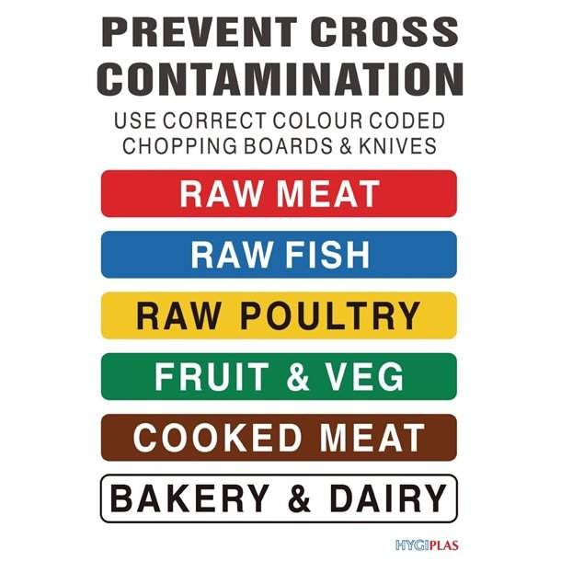
Daily & Monthly Kitchen Audits
Effective and regular cleaning and sanitising reduce the potential for food poisoning bacteria to grow, pests to be attracted and cross contamination to occur.
There should be no accumulation of garbage, recycled matter, and food waste, dirt, grease or other visible matter on fixtures, fittings and equipment that may contaminate food.

Cleaning Schedules
A cleaning schedule is a live document that will assist in making sure that an appropriate level of cleanliness is maintained, and tasks are not inadvertently missed.
It is important to make your schedule practical.
The schedule should focus on tasks that are not routine and may be overlooked if not allocated to a time and a person. The schedule may also outline which tasks are ‘priority tasks’ that must be completed to ensure food safety. This will assist on busy days or if short-staffed.
Positioning
Position the cleaning schedule in an area that is regularly and easily accessed or place individual sections of the schedule in the area concerned.
Staff are to fill in their name and signature as the task is completed.
There are 3 levels of cleaning rosters.
Daily Sanitation Schedule
Fill in the Daily Sanitation Schedule with items that must be cleaned and sanitised. daily.
Monthly Sanitation Schedule
Fill in the Monthly Sanitation Schedule with items that must be cleaned and sanitised monthly.
Weekly Sanitation Schedule
Fill in the Weekly Sanitation Schedule with items that must be cleaned and sanitised weekly.

The Pizza Section
The Pizza section function is obvious...its where all the pizzas get prepared and cooked!
But it's not just limited to pizza, this section also produces garlic breads, flatbreads and even desserts.
For the best result, make sure you have a hot oven running at 400-500° C and a sharp pizza cutter!

Section Equipment
The two very important pieces of equipment you must understand and maintain in this section are:
- The Pizza Oven
- The Dough Mixer

The Pizza Oven
There are many types of Pizza ovens:
- Gas conveyor
- Electric conveyor
- Woodfired oven
- Woodfired + gas boost
- Deck ovens (electric + gas combination)
Tips to maintaining your pizza oven:
- Service regularly
- Thoroughly cleaned at end of each shift
- Keep all jets and interior free from obstructions
- Lubricate moving parts

The Dough Mixer
A dough mixer is used for kneading large quantities of dough. It is electrical and includes in-built timers and other controls, making you more efficient.
Tips to Maintaining Your Dough Mixer:
- Clean it thoroughly after use
- Take it apart and check for flour build-up
- Have it serviced on a regular basis
- Check the safety stops
Important: Always make sure the dough mixer is serviced regularly and is in good working condition. If this piece of equipment fails, you may be required to knead 20kg of dough by hand. Not a pleasant job!

Mis en Place
Here's a short checklist of what's you'll need on hand for the Pizza section:
- Pizza toppings: Topping prepped and also backed-up.
- Sauce spoon: For applying sauce to pizza bases.
- Pizza trays: For cooking pizza on.
- Pizza cutter: For slicing pizza.
- Pizza boxes: For pick-up & delivery.

Making Dough
Activating the Yeast
The first step to preparing pizza dough is to activate the yeast by:
- Adding yeast to a bowl.
- Adding warm water (37°C).
- Adding a dash of sugar.
Note: Sugar acts as a catalyst to activate the yeast.
Making the Dough
Into the dough mixer, add:
- Water.
- Dissolve in salt.
- Add flour and stir.
- Add yeast mix.
- Add oil.
Note: Pro-Tip: Always keep salt away from the yeast mixture as it can kill the yeast and your dough will not rise.
Preparing Dough Balls:
- Cut away length of dough
- Slice into portions and weigh
- Create a ball in hands
- Finish by rolling on bench
Note: Space dough balls in trays with plenty of room to allow for rising.

Making a Pizza
Now the fun part...adding toppings and flavours to the Pizza.
Preparing the Pizza Base
- Evenly flatten the dough and create an edge.
- Stretch out the edges and form a crust.
- Stretch out the middle evenly using your palms.
- Dust off any excess flour and place on a pizza tray.
Note: Semolina is often used when stretching dough. It is a coarser form of wheat that helps give dough a great texture and also adds flavour.
Steps to Preparing a Pizza:
- Add tomato sauce (from middle outwards to edge).
- Add cheese.
- Add toppings (work from the outside edge back into middle).
- Place in pizza oven and cook.
- Cut into slices & serve!
Note: Always maintain a finger width of space for the crust.

The Fry Section
Welcome to the Fry Section!
This module is designed to give you a fundamental understanding of the Fry Section.
You will learn how to set the section up, manage your oil as well as how to prepare and cook Chicken Schnitzel and Battered Fish & Chips.
--------------------------------------------------------------------------------------------------------------
The fryer section often accounts for 30% or more of a kitchen's food output - so it's a very important section to get right. Common foods coming out of this section include, chips, calamari, schnitzels, fish, and chicken.
Note: The most important thing to know about the fry section is oil, make sure its fresh and at the right cooking temperature.
Section Equipment
The main piece of equipment you'll be working with in this section are the deep fryers - and the most important job of the Chef de Partie is to maintain clean fresh oil all day long!
Important: Clean and fresh oil will provide you with the best quality dish every time, so look after your oil!
Maintaining your fryer oil consists of a collection of positive cooking habits that are practiced constantly:
- Shaking off ice crystals before frying frozen food products.
- Not salting food above the fryer oil to reduce debris.
- Filtering your oil at least once a day and as often as necessary to increase oil longevity.
- Using a skimmer to pull larger sediments out of the oil can buy you some time before filtering the oil is necessary.
- Allowing your oil to cool below cooking temperatures during slower hours of the day can reduce the rate at which your oil breaks down.
Pro-tip: To preserve oil, turn fryers off during service breaks and wait longer to turn fryers on, 11am as opposed to 10am.
Total Polar Materials
During use, frying fats undergo chemical deterioration. This leads to the formation of compounds that are more polar than the triacylglycerols of the fat. Collectively these are called total polar material (TPM), and the mass concentration of TPM is used as an indicator of the quality of frying fats.
Checking Total Polar Material
Testing the Total Polar Materials (TPM) component in the oil this can be done with a electronic testing device or strips. The acceptable threshold for TPM in Australia is <25%.

Mis en Place
Here's a short checklist of what's you'll need on hand for the Fry section:
- Chopping board: With wet chux underneath to avoid slippage.
- Stainless steel bowls: For chips, fish etc.
- Tongs: Essential for handling food out of the frier.
- Seasoning: Depending on main dishes being prepared.
- Damp cloths/ chux: For cleaning as you go.

Cooking Chicken Schnitzel
Now it's finally time to do some cooking!
Watch the video above to have Chef Paul take you through the process of preparing and cooking a Chicken Schnitzel.
Steps to preparing chicken schnitzel:
- Remove tenderloin.
- Slice fillet down the middle (keep joined).
- Apply go-between and flatten evenly.
- Coat chicken in flour and then egg-wash.
- Coat in seasoned breadcrumbs.
- Cook schnitzel at 160°C until golden brown.
- Allow oil to drain before plating.
Pro-Tip: Use the chicken tenderloin for other dishes to avoid wastage.

Cooking Battered Fish & Chips
Let's now move onto a Fry favourite...Fish & Chips.
Watch the video above to have Chef Paul take you through the process of preparing and cooking a delicious plate of fish & chips.
Steps to preparing battered Fish & Chips
- Coat fish fillets in flour and then fresh batter.
- Allow excess batter to drip off.
- Gently lay fish into fryer to avoid sinking.
- Turn fish to ensure even browning.
- Remove and drain excess oil.
- Season and plate.
Note: Fish is cooked at a higher heat and for less time to keep the meat tender.

Closing & Cleaning
It's the end of the shift - time to close the section. Follow the steps below for a professional close.
Steps to closing the Fry section:
- Turn the fryers off.
- Top up service fridges in full airtight containers.
- Take bowls and utensils to scullery.
- Wipe down all benches & walls with hot soapy water.
- Filter or dump oil (clean fryer if dumping).
- Spray leave-on sanitiser before leaving.
Note: Discard any old batter or flour to avoid cross contamination.

The Pans Section
Welcome to the Pans Section!
This module is designed to give you a fundamental understanding of the Pans Section.
You will learn how to set-up the section, fillet, cook and service a beautiful dish of Atlantic Salmon.
-----------------------------------------------------------------------------------------------------
The Pans section is one of the more complex sections to work, as this is where a variety of dishes are prepared that all require different timings. Hence this section is generally recommended for more experienced chefs.
The dishes coming out of this section include, pan-fried fish, pastas, veal, risotto as well as sauces.
The performance of the pans section can either MAKE or BREAK a service!

Section Equipment
The most important pieces of equipment in the pans section are your stove-top and oven.
Things to check every time you start a shift are:
Stove-tops:
- Cast-iron tops clean.
- All jets firing and free from carbon build-up.
Oven:
- Clean and in good working condition.
Setting for Success
Here's a quick checklist of what's you'll need on hand for the Pans section:
- Pans: A variety of sizes for different dishes.
- Tongs: At least 2 - 3 sets.
- Cloths: Dry cloths for carrying pans and wet for wiping down areas.
- Chilled prep: Ready-to-go prep stored in ice-bays.
- Back-up prep: Full, airtight containers stored in service fridges.

Filleting & Portioning Fish
In this section, Chef Paul will show you how to fillet, portion and store an Atlantic Salmon in readiness for cooking.
Steps to Filleting a Fish:
- Slice across the back of the head.
- Cut down back of the fish, above the spine.
- Continue to run knife down back to separate filet from the bone.
- Slice across the tail.
- Run knife up fish to remove fillet.
- Remove belly fat and any extra bones.
- Remove pin bones with deboning tweezers.
- Trim edges & square-off fillet.
Pro-tip: don't squeeze tweezers too hard as they can snap the bones and leave embedded in the fish
Steps to Portioning and Storing Fish Fillets:
- Prepare a kitchen scale with cling film.
- Prepare a gastro tray with chux cloth.
- Cut 180g - 200g portions.
- Store fillets tightly together in container.
- Add another chux cloth for a 2nd layer.
- Double-wrap, label & store.
Pro-tip: Always cover your scales when weighing any food items to avoid cross-contamination.

Cooking Fish
Now it's time to prepare and serve this fish that we've so lovingly prepared.
Steps to Cooking Atlantic Salmon:
Place the fish fillet skin-up in a tray.
- Season the skin with salt.
- Heat -up the pan with a dash of oil.
- Place the fillet/s flesh-down onto the pan for 10-15sec then turn to skin side.
- Flatten the fillet out slightly for an even fry.
- Place in a 200°C oven for 6mins (180g).
- Give it a final check & then plate.
Pro-tip: Adding oil to the pan helps to create a crispier skin.

Closing & Cleaning
It's the end of the shift...time to close the section. Follow the steps below for a professional close.
- Take all utensils/ pans to scullery.
- Replenish all prep/ stock.
- Wrap topped-up stock airtight & store.
- Complete prep & orders lists.
- Turn off equipment (& let cool-down).
- Scrub benches/ walls.
- Scrub and clean gas top/ oven.

The Grill Section
Welcome to the Grill Section!
This module is designed to give you a fundamental understanding of the Grill Section.
You will learn how to set-up and maintain the section, as well as how to trim, portion, and grill the perfect steak.
-------------------------------------------------------------------------------------------------------------
The Grill section is where all the grilling is done in a kitchen, with the most common foods being, steaks, skewers, fish, poultry, lamb, and pork.
Your main piece of equipment in this section is your Grill. The most important point about this piece of equipment are:
- Have a clean grill, cleared of any major carbon build-up.
- Have very hot heat to make sure you grill (and not stew) any meat.
The Golden Rule: grill must always be very hot for best results!

Mis en Place
Here's a short checklist of what's you'll need on hand for the Grill section:
- Chopping board knife: With wet chux underneath to avoid slippage.
- Oil & salt: Depending on main dishes being prepared.
- Stainless steel bowls: For chips, fish etc.
- Tongs: Essential for handling food out of the frier.
- Scraper: For scraping excess fat from the grill.
- Damp cloths/ chux: For cleaning as you go.

Trimming & Portioning Steak
How to trim a steak:
- Remove the wrap.
- Dry off the excess blood.
- Even out the fat (if needed).
- Remove the sinew.
- Remove the excess fat.
Pro-tip: You can use the excess fat as if it was oil.
How to portion a steak:
- Square-up the ends.
- Prepare a scale with wrap.
- Slice slow even cut.
- Check the weight of each steak.
- Place steaks in storage container.
- Label the container clearly and wrap airtight.
Pro-tip: by making long, smooth cut strokes you avoid leaving 'steps' in the meat.

Cooking Steak
After preparing the steak - it's finally time to cook it!
Steps to cooking the perfect steak:
- Ensure grill is on and very hot.
- Season each side of the steak with oil and salt.
- Place steak on the grill (the length of time will depend on thickness of the steak and the cooking temperature).
- Rotate the steak 45° to create char marks.
- Turn the steak over & repeat.
- Check the temperature (see chart below).
- Allow the steak to rest.
Pro-tip: Always season your steak off the grill to avoid flash-fires.
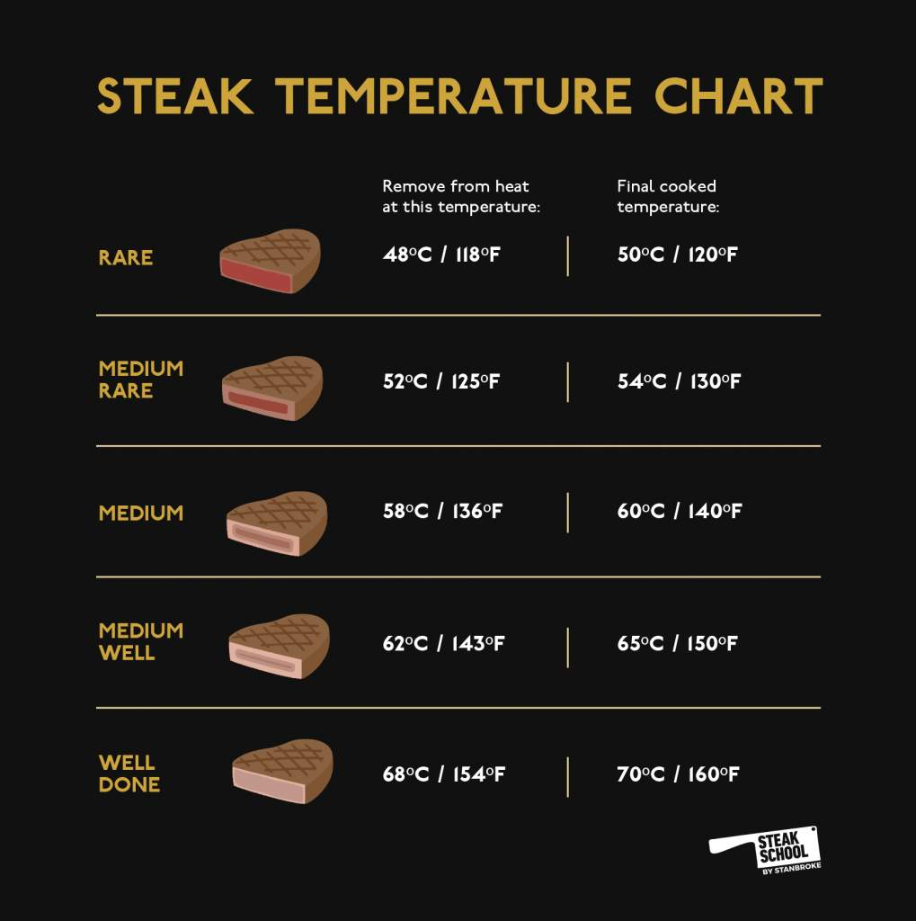

Closing & Cleaning the Section
It's the end of the shift - time to close the section. Follow the steps below for a professional close.
Steps to closing the Grill section:
- Take the cutting boards and equipment to the scullery.
- Turn of grill and clean with grill brush.
- Wipe down all surfaces with hot soapy water.
- Top up the service fridges.
- Complete prep list for next day.

The Pass Section
Welcome to the Pass Section!
This module is designed to give you a fundamental understanding of the Pass.
You will learn how to manage dockets, handle customer requests/ dietaries and deal with complaints (yes, that part of the job too...)
--------------------------------------------------------------------------------------------------------------
The Pass section is the end of the line, the final set of hands the food sees before the customer receives it.
Areas to constantly watch for on the Pass:
- Food presentation: Is the meal well-presented and served with all relevant accompaniments?
- Portion sizes: Are the servings (especially protein) on par with your menu standards and not too large/ too small?
- Cooked correctly: Is the cooking temperature correct? Does anything look over or under cooked?
The pass is the border between kitchen and customers and a cool and level head must kept at all times.
It can be super difficult at times having to keep the kitchen going at a fast and efficient pace and to then be able to deal with a customer with a slow, steady, friendly and helpful demeanour.

Managing Dockets & Customers
Managing dockets well is the key to managing customer well.
When running the Pass, always work to a first-in/ first-out philosophy as timing is critical.
The 3 areas to look are on each docket are:
- Check number: It may be either table or buzzer number.
- Check items: Look for number of dishes and any custom notes or requests.
- Check time: Keep an eye on time and works to a first-in/ first-out methodology.
Pro-tip: If you do get overwhelmed (and it will happen), take a moment to STOP, REVIVE & SURVIVE.

Managing Complaints
In a busy restaurant or bistro, there will always be small mistakes with food, longer than expected wait-times etc.
It’s important to remember that communication is key - the better you communicate with your colleagues and customers, the easier your shift will be!
Here a couple of common complaints and how to handle them.
- Wait Times: If a customer has waited and unreasonable time for their food, find out what’s going on with the food, express it and give the customer a time that the food will be ready.

If this is still a non-reasonable time a manager should be contacted to sort out some compensation.

- Incorrect Order: Resolve by fixing the meal as soon as possible and apologise for the wait.

Do not try and find out what happened, fix this issue, and then look to identify the cause at a later stage.

Managing Requests & Dietaries
How we handle dietary requirements will either win or lose us business.
Dietaries requirements have become an increasingly important part of how we attend to our customer’s needs - and if we address them well, they will be inclined to visit us again.
In general, there are two types of dietaries:
- Allergies & Intolerances: Consuming food items containing allergens can cause serious illness and even death.

- Preferences: Customer simply do not like certain food items and prefer not to eat them.
No matter the origins, our job is to ensure that our customer needs are catered to the best of our abilities. Obviously, extra care must be taken when dealing with allergies, as the consequences can be dire. The top 14 food allergens are listed below.
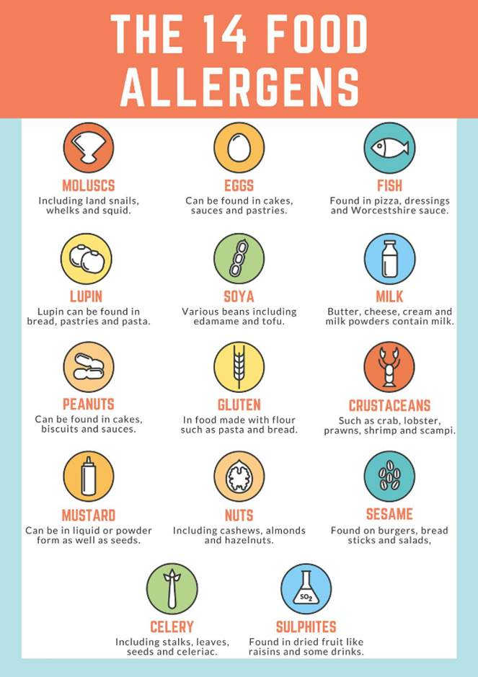
To ensure you can manager customer's dietary requirements to an excellent level, the following areas are mandatory:
- Knowing your menu and dish ingredients: A cheat-sheet of dishes and ingredients should be prepared and made available to all staff to study.
- Familiarise yourself with all bought-in ingredients: Check the labels and speak to the suppliers about any potential cross-contamination risks.
- Prepare a neutral area where food for people with life-threatening allergies may be prepared: Use a different set of utensils and equipment plate-up in a neutral area.

Opening & Closing the Pass
The Pass is where customers come and interact with the kitchen area, so it's imperative for it to look presentable, clean and organised.
A few important areas to check when setting up the Pass, are:
- Docket paper rolls are topped-up.
- All cutlery is clean and replenished.
- Serviettes are topped-up with back-ups nearby.
- All condiments (sauces, salt/ pepper etc) replenished.
- Heat lamps turned on just prior to service starting.
Note: When closing the Pass, ensure all benches and shelves are thoroughly scrubbed down and switch heat lamps off before leaving.

